**LAPORAN TUGAS AKHIR**

**BAHASA PEMROGRAMAN VISUAL**

**“SUDOKU GAME”**



Oleh:

Galih Prasetyo (110533430521 / S1 PTI B 2011)  
Muhammad Badrun (110533430508 / S1 PTI B 2011)  
Indri Widyarti (110533406971 / S1 PTI A 2011)  
Muhammad Andika Prastomo (110533430566 / S1 PTI C 2011)

**UNIVERSITAS NEGERI MALANG**

**FAKULTAS TEKNIK**

**JURUSAN TEKNIK ELEKTRO**

**PRODI S1 PENDIDIKAN TEKNIK INFORMATIKA 2011**

**MEI , 2013**

**SUDOKU GAME**

1. **Pendahuluan**

Dampak globalisasi sudah sangat kental sekali dirasakan oleh seluruh orang di muka bumi ini. Globalisasi ini selain membawa dampak positif, juga membawa dampak negatif terhadap kehidupan masyarakat. Dampak positif Globalisasi tersebut diantaranya yaitu setiap orang mudah untuk memperoleh informasi dan ilmu pengetahuan, mudah melakukan komunikasi, memacu untuk meningkatkan kualitas diri, dan mudah memenuhi kebutuhan. Sedangkan dampak negatif yang disebabkan oleh globalisasi ini diantaranya menimbulkan perilaku konsumtif.

Tidak hanya itu, dampak globalisasi juga nampak dalam dunia hiburan. Salah satu bentuk hiburan diantaranya adalah game. Game sangat berkembang pesat seiring dengan kemajuan teknologi komputer. Game sangat banyak diminati baik dari kalangan anak-anak, remaja sampai dewasa. Akan tetapi game yang selama ini kita temui kurang bersifat edukatif (mendidik), dan kebanyakan game-game yang telah ada hanya untuk memberikan hiburan semata tanpa adanya feedback positif yang didapat apabila kita memainkan game tersebut.

Untuk itulah dengan game sudoku ini mungkin dapat meminimalisasi dari penggunaan game-game yang telah beredar. Sudoku adalah permainan penempatan angka berbasis logika. Papan permainan berbentuk kumpulan grid 9×9. Konsep dari permainan sudoku ini adalah angka dibatasi hanya muncul sekali. Angka yang digunakan adalah 1 sampai 9. Artinya, pada setiap baris, kolom, maupun region hanya dimungkinkan setiap angka muncul sekali tanpa perulangan, dan artinya juga, setiap angka harus muncul pada setiap baris, kolom dan region. Terakhir, yang juga menjadi dasar permainan sudoku, adalah bahwa setiap soal sudoku hanya memiliki satu penyelesaian tunggal. Ini yang menentukan apakah sebuah soal sudoku valid atau tidak. Game sudoku ini dapat melatih kecepatan dan ketangkasan anak dalam berpikir kreatif dalam menyelesaikan suatu masalah, karena pada saat mengisi grid (kotak) yang kosong tersebut dikontrol oleh waktu, sehingga apabila terlalu lama dalam mengisinya maka score yang didapat akan berkurang 2 setiap 2 menit sekali. Pembuatan game ini dibuat menggunakan Microsoft Visual basic 2012. Pada game ini terdiri dari 2 level yang berbeda yaitu NormalLevel dan HardLevel. Selain itu ada menu new game untuk memulai game baru.

1. **Tujuan**

Tujuan dari pembuatan game ini adalah :

1. Untuk memenuhi tugas akhir pemrograman visual
2. Untuk membantu setiap anak-anak untuk berpikir kreatif dan untuk melatih kecerdasan otak mereka dalam memecahan suatu masalah
3. Sebagai media hiburan bagi pengguna dengan permainan dari game sudoku yang kreatif
4. **Manfaat**

Manfaat dari pembuatan game ini adalah :

1. Bagi Pembuat Game
2. Sebagai sarana dalam penerapan (implementasi) dari ilmu yang telah didapat dalam matakuliah Pemograman Visual
3. Bagi Pengguna
4. Dapat menjadi sarana untuk peningkatan kekritisan atau kecermatan anak dalam menyelasikan suatu masalah melalui game yang mendidik
5. Dapat menjadi sarana hiburan yang kreatif da tidak monoton.
6. **Source Code**
7. **FormScore**

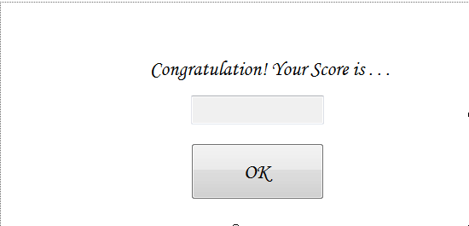

|  |
| --- |
| Public Class FormScore  Private Sub Button1_Click(sender As Object, e As EventArgs) Handles Button1.Click  Me.Close()  End Sub  Private Sub Score_Load(sender As Object, e As EventArgs) Handles MyBase.Load  TextBox1.Text = HardLevel.score  End Sub  End Class |

1. **Form NormalLevel**

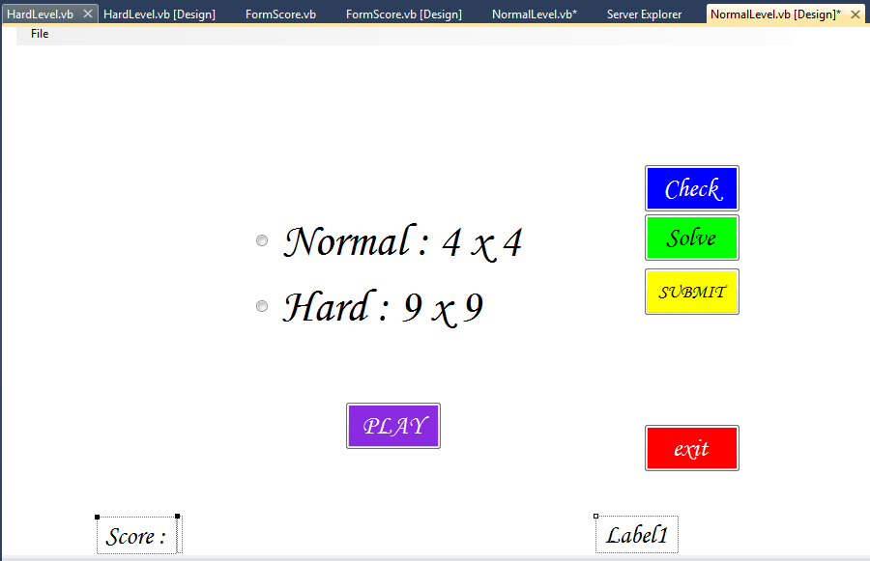

|  |
| --- |
| Public Class NormalLevel  Public box As Integer = 9  Dim Jam, Menit, Detik, mDetik As Integer  Dim hard As Integer = 0  Dim hardini As Integer = 0  Dim normal As Integer = 0  Dim normalini As Integer = 0  Dim mulai As Integer = 1  Dim check As Integer = 0  Dim backtracking As Boolean = False  Dim Bold As Font = New Font(Me.Font.FontFamily, Me.FontHeight + 17, FontStyle.Bold)  '----------------------------------------------------  ' FUNGSI RANDOM!  '----------------------------------------------------  Dim i As Integer  Dim j As Integer  Public Function GetRandom(ByVal Min As Integer, ByVal Max As Integer) As Integer  Dim Generator As System.Random = New System.Random()  Return Generator.Next(Min, Max)  End Function  Class sudoku_textbox  Inherits TextBox  Protected Overrides Sub OnKeyPress(ByVal e As System.Windows.Forms.KeyPressEventArgs)  If Char.IsDigit(e.KeyChar) Or e.KeyChar = " " Or e.KeyChar = ControlChars.Back Then  e.Handled = False  Else  e.Handled = True  End If  If e.KeyChar = " " Or e.KeyChar = "0" Then  e.KeyChar = ControlChars.Back  End If  If HardLevel.box = 4 Or NormalLevel.box = 4 Then  If e.KeyChar = "5" Or e.KeyChar = "6" Or e.KeyChar = "7" Or e.KeyChar = "8" Or e.KeyChar = "9" Then  e.KeyChar = ControlChars.Back  End If  End If  End Sub  End Class  Dim cell(0 To box - 1, 0 To box - 1) As sudoku_textbox  Dim grid(0 To box - 1, 0 To box - 1) As String  Private Sub Form1_Load(ByVal sender As Object, ByVal e As System.EventArgs) Handles Me.Load  Button2.Enabled = True  ButtonSolve.Enabled = True  If HardLevel.RadioButton2.Checked And mulai = 1 Then  Label1.Text = "00 : 00 : 00,00"  Timer1.Enabled = True  Button1.Visible = True  Button2.Visible = False  Button3.Visible = False  ButtonSolve.Visible = False  Button4.Visible = True  RadioButton2.Visible = False  RadioButton3.Visible = False  box = 4  normal = 1  normalini = 1  hard = 0  hardini = 0  normal_cell()  random_normal()  mulai = 0  ElseIf HardLevel.RadioButton3.Checked And mulai = 1 Then  Label1.Text = "00 : 00 : 00,00"  Timer1.Enabled = True  Button1.Visible = True  Button2.Visible = True  Button3.Visible = False  ButtonSolve.Visible = True  Button4.Visible = True  RadioButton2.Visible = False  RadioButton3.Visible = False  box = 9  normal = 0  normalini = 0  hard = 1  hardini = 1  hard_cell()  random_hard()  mulai = 0  ElseIf hard = 1 And hardini = 1 And box = 9 Then  'Label1.Text = "00 : 00 : 00,00"  Me.Hide()  HardLevel.box = 4  HardLevel.Show()  Else  Label1.Text = "00 : 00 : 00,00"  Timer1.Enabled = True  Button1.Visible = True  Button2.Visible = True  Button3.Visible = False  ButtonSolve.Visible = True  Button4.Visible = True  RadioButton2.Visible = False  RadioButton3.Visible = False  box = 4  normal = 1  normalini = 1  hard = 0  hardini = 0  For x As Integer = 0 To box - 1  For y As Integer = 0 To box - 1  cell(x, y).ReadOnly = False  cell(x, y).BackColor = Color.White  cell(x, y).Text = ""  cell(x, y).Show()  Next  Next  random_normal()  End If  End Sub  '-----------------------------------------------------------------------------------------------------------  ' AREA NORMAL LEVEL COMMAND  '-----------------------------------------------------------------------------------------------------------  '-----------------------------  ' Normal Random  '-----------------------------  Private Sub random_normal()  For x As Integer = 0 To 3  If x = 0 Then  i = 0  j = GetRandom(1, 2)  cell(i, j).Text = 1  ElseIf x = 1 Then  i = 1  j = GetRandom(2, 3)  cell(i, j).Text = 2  ElseIf x = 2 Then  i = 2  j = GetRandom(3, 4)  cell(i, j).Text = 3  ElseIf x = 3 Then  i = 3  j = GetRandom(1, 3)  cell(i, j).Text = 4  End If  Next  HardLevel.score = 0  Label3.Text = HardLevel.score  End Sub  '***************************  ' Cell Normal 4x4  '***************************  Private Sub normal_cell()  Dim xxtra As Integer  Dim yxtra As Integer  For x As Integer = 0 To box - 1  For y As Integer = 0 To box - 1  cell(x, y) = New sudoku_textbox  cell(x, y).AutoSize = False  cell(x, y).ReadOnly = False  cell(x, y).Font = Bold  cell(x, y).Text = ""  cell(x, y).Width = 50  cell(x, y).Height = 50  cell(x, y).MaxLength = 1  cell(x, y).TextAlign = HorizontalAlignment.Center  If normal = 0 And normal = 0 Then  cell(x, y).Visible = False  Else  cell(x, y).Visible = True  End If  xxtra = 0  yxtra = 0  If x > 1 Then  xxtra = 4  End If  If x > 3 Then  xxtra = 8  End If  If y > 1 Then  yxtra = 4  End If  If y > 3 Then  yxtra = 8  End If  cell(x, y).Location = New Point(150 + x * 50 + xxtra, 150 + 50 * y + yxtra)  'End If  'cell(x, y).Location = New Point(x * 20, y * 20)  Me.Controls.Add(cell(x, y))  AddHandler cell(x, y).TextChanged, AddressOf cell_changed_normal  Next  Next  End Sub  '***************************  ' Ganti isi Cell Normal  '***************************  Private Sub cell_changed_normal()  If backtracking Then Return  For x As Integer = 0 To box - 1  For y As Integer = 0 To box - 1  grid(x, y) = cell(x, y).Text  cell(x, y).ForeColor = Color.Black  cell(x, y).BackColor = Color.White  Next  Next  HardLevel.score = HardLevel.score + 2  Label3.Text = HardLevel.score  For x = 0 To box - 1  For y = 0 To box - 1  If check_rows_normal(x, y) Then  If check_columns_normal(x, y) Then  If Not check_box_normal(x, y) Then  cell(x, y).ForeColor = Color.Red  cell(x, y).BackColor = Color.Yellow  HardLevel.score = HardLevel.score - 2  Label3.Text = HardLevel.score  End If  Else  cell(x, y).ForeColor = Color.Red  cell(x, y).BackColor = Color.Yellow  HardLevel.score = HardLevel.score - 2  Label3.Text = HardLevel.score  End If  Else  cell(x, y).ForeColor = Color.Red  cell(x, y).BackColor = Color.Yellow  HardLevel.score = HardLevel.score - 2  Label3.Text = HardLevel.score  End If  Next  Next  End Sub  '***************************  ' Cek Baris Cell Normal  '***************************  Function check_rows_normal(ByVal xsender, ByVal ysender) As Boolean  Dim noclash As Boolean = True  For x As Integer = 0 To box - 1  If grid(x, ysender) <> "" Then  If x <> xsender Then  If grid(x, ysender) = grid(xsender, ysender) Then  noclash = False  End If  End If  End If  Next  Return noclash  End Function  '***************************  ' Cek Kolom Cell Normal  '***************************  Function check_columns_normal(ByVal xsender, ByVal ysender) As Boolean  Dim noclash As Boolean = True  For y As Integer = 0 To box - 1  If grid(xsender, y) <> "" Then  If y <> ysender Then  If grid(xsender, y) = grid(xsender, ysender) Then  noclash = False  End If  End If  End If  Next  Return noclash  End Function  '***************************  ' Cek Box Cell Normal  '***************************  Function check_box_normal(ByVal xsender, ByVal ysender) As Boolean  Dim noclash As Boolean = True  Dim xstart As Integer  Dim ystart As Integer  If xsender < 2 Then  xstart = 0  ElseIf xsender < 4 Then  xstart = 2  End If  If ysender < 2 Then  ystart = 0  ElseIf ysender < 4 Then  ystart = 2  End If  For y As Integer = ystart To (ystart + 1)  For x As Integer = xstart To (xstart + 1)  If grid(x, y) <> "" Then  If Not (x = xsender And y = ysender) Then  If grid(x, y) = grid(xsender, ysender) Then  noclash = False  End If  End If  End If  Next  Next  Return noclash  End Function  '***************************  ' Problem Solve Normal  '***************************  Function backtrack_normal(ByVal x As Integer, ByVal y As Integer) As Boolean  Dim numbers As Integer = 1  If grid(x, y) = "" Then  Do  grid(x, y) = CStr(numbers)  If check_rows_normal(x, y) Then  If check_columns_normal(x, y) Then  If check_box_normal(x, y) Then  y = y + 1  If y = box Then  y = 0  x = x + 1  If x = box Then Return False  End If  If backtrack_normal(x, y) Then Return True  y = y - 1  If y < 0 Then  y = box - 1  x = x - 1  End If  End If  End If  End If  numbers = numbers + 1  Loop Until numbers = box + 1  grid(x, y) = ""  Return False  Else  y = y + 1  If y = box Then  y = 0  x = x + 1  If x = box Then Return True  End If  Return backtrack_normal(x, y)  End If  ' End If  End Function  '-----------------------------------------------------------------------------------------------------------  ' AREA HARD LEVEL COMMAND  '-----------------------------------------------------------------------------------------------------------  '-----------------------------  ' Normal Random  '-----------------------------  Private Sub random_hard()  For x As Integer = 0 To 8  '----------------------------------------------  ' Random Baris 1 - 3 | ( 0 - 2 )  '----------------------------------------------  If x = 0 Then  i = GetRandom(0, 2)  j = GetRandom(0, 2)  cell(i, j).Text = GetRandom(1, 2)  cell(i, j).ReadOnly = True  cell(i, j).BackColor = Color.Blue  i = GetRandom(0, 2)  j = GetRandom(0, 2)  cell(i, j).Text = GetRandom(3, 4)  cell(i, j).ReadOnly = True  cell(i, j).BackColor = Color.Blue  ElseIf x = 1 Then  i = GetRandom(0, 2)  j = GetRandom(3, 5)  cell(i, j).Text = GetRandom(5, 6)  cell(i, j).ReadOnly = True  cell(i, j).BackColor = Color.Blue  i = GetRandom(0, 2)  j = GetRandom(3, 5)  cell(i, j).Text = GetRandom(7, 8)  cell(i, j).ReadOnly = True  cell(i, j).BackColor = Color.Blue  ElseIf x = 2 Then  i = GetRandom(0, 2)  j = GetRandom(6, 8)  cell(i, j).Text = GetRandom(2, 3)  cell(i, j).ReadOnly = True  cell(i, j).BackColor = Color.Blue  i = GetRandom(0, 2)  j = GetRandom(6, 8)  cell(i, j).Text = GetRandom(4, 5)  cell(i, j).ReadOnly = True  cell(i, j).BackColor = Color.Blue  '----------------------------------------------  ' Random Baris 4 - 6 | ( 3 - 5 )  '----------------------------------------------  ElseIf x = 3 Then  i = GetRandom(3, 5)  j = GetRandom(0, 2)  cell(i, j).Text = GetRandom(5, 6)  cell(i, j).ReadOnly = True  cell(i, j).BackColor = Color.Blue  i = GetRandom(3, 5)  j = GetRandom(0, 2)  cell(i, j).Text = GetRandom(7, 8)  cell(i, j).ReadOnly = True  cell(i, j).BackColor = Color.Blue  ElseIf x = 4 Then  i = GetRandom(3, 5)  j = GetRandom(3, 5)  cell(i, j).Text = GetRandom(2, 3)  cell(i, j).ReadOnly = True  cell(i, j).BackColor = Color.Blue  i = GetRandom(3, 5)  j = GetRandom(3, 5)  cell(i, j).Text = GetRandom(4, 5)  cell(i, j).ReadOnly = True  cell(i, j).BackColor = Color.Blue  ElseIf x = 5 Then  i = GetRandom(3, 5)  j = GetRandom(6, 8)  cell(i, j).Text = GetRandom(1, 2)  cell(i, j).ReadOnly = True  cell(i, j).BackColor = Color.Blue  i = GetRandom(3, 5)  j = GetRandom(6, 8)  cell(i, j).Text = GetRandom(3, 4)  cell(i, j).ReadOnly = True  cell(i, j).BackColor = Color.Blue  '----------------------------------------------  ' Random Baris 7 - 9 | ( 6 - 8 )  '----------------------------------------------  ElseIf x = 6 Then  i = GetRandom(6, 8)  j = GetRandom(0, 2)  cell(i, j).Text = GetRandom(2, 3)  cell(i, j).ReadOnly = True  i = GetRandom(6, 8)  j = GetRandom(0, 2)  cell(i, j).Text = GetRandom(4, 5)  cell(i, j).ReadOnly = True  ElseIf x = 7 Then  i = GetRandom(6, 8)  j = GetRandom(3, 5)  cell(i, j).Text = GetRandom(1, 2)  cell(i, j).ReadOnly = True  i = GetRandom(6, 8)  j = GetRandom(3, 5)  cell(i, j).Text = GetRandom(3, 4)  cell(i, j).ReadOnly = True  ElseIf x = 8 Then  i = GetRandom(6, 8)  j = GetRandom(6, 8)  cell(i, j).Text = GetRandom(6, 7)  cell(i, j).ReadOnly = True  i = GetRandom(6, 8)  j = GetRandom(6, 8)  cell(i, j).Text = GetRandom(8, 9)  cell(i, j).ReadOnly = True  End If  Next  HardLevel.score = 0  Label3.Text = HardLevel.score  End Sub  '***************************  ' Cell Hard 9x9  '***************************  Private Sub hard_cell()  Dim xxtra As Integer  Dim yxtra As Integer  For x As Integer = 0 To box - 1  For y As Integer = 0 To box - 1  cell(x, y) = New sudoku_textbox  cell(x, y).AutoSize = False  cell(x, y).ReadOnly = False  cell(x, y).Font = Bold  cell(x, y).Text = ""  cell(x, y).Width = 50  cell(x, y).Height = 50  cell(x, y).MaxLength = 1  cell(x, y).TextAlign = HorizontalAlignment.Center  If normal = 0 And hard = 0 Then  cell(x, y).Visible = False  Else  cell(x, y).Visible = True  End If  xxtra = 0  yxtra = 0  If x > 2 Then  xxtra = 4  End If  If x > 5 Then  xxtra = 8  End If  If y > 2 Then  yxtra = 4  End If  If y > 5 Then  yxtra = 8  End If  cell(x, y).Location = New Point(75 + x * 50 + xxtra, 75 + 50 * y + yxtra)  'End If  'cell(x, y).Location = New Point(x * 20, y * 20)  Me.Controls.Add(cell(x, y))  AddHandler cell(x, y).TextChanged, AddressOf cell_changed_hard  Next  Next  End Sub  '***************************  ' Ganti isi Cell Hard  '***************************  Private Sub cell_changed_hard()  If backtracking Then Return  For x As Integer = 0 To box - 1  For y As Integer = 0 To box - 1  grid(x, y) = cell(x, y).Text  cell(x, y).ForeColor = Color.Black  cell(x, y).BackColor = Color.White  Next  Next  HardLevel.score = HardLevel.score + 2  Label3.Text = HardLevel.score  For x = 0 To box - 1  For y = 0 To box - 1  If check_rows_hard(x, y) Then  If check_columns_hard(x, y) Then  If Not check_box_hard(x, y) Then  cell(x, y).ForeColor = Color.Red  cell(x, y).BackColor = Color.Yellow  HardLevel.score = HardLevel.score - 2  Label3.Text = HardLevel.score  End If  Else  cell(x, y).ForeColor = Color.Red  cell(x, y).BackColor = Color.Yellow  HardLevel.score = HardLevel.score - 2  Label3.Text = HardLevel.score  End If  Else  cell(x, y).ForeColor = Color.Red  cell(x, y).BackColor = Color.Yellow  HardLevel.score = HardLevel.score - 2  Label3.Text = HardLevel.score  End If  Next  Next  End Sub  '***************************  ' Cek Baris Cell Hard  '***************************  Function check_rows_hard(ByVal xsender, ByVal ysender) As Boolean  Dim noclash As Boolean = True  For x As Integer = 0 To box - 1  If grid(x, ysender) <> "" Then  If x <> xsender Then  If grid(x, ysender) = grid(xsender, ysender) Then  noclash = False  End If  End If  End If  Next  Return noclash  End Function  '***************************  ' Cek Kolom Cell Hard  '***************************  Function check_columns_hard(ByVal xsender, ByVal ysender) As Boolean  Dim noclash As Boolean = True  For y As Integer = 0 To box - 1  If grid(xsender, y) <> "" Then  If y <> ysender Then  If grid(xsender, y) = grid(xsender, ysender) Then  noclash = False  End If  End If  End If  Next  Return noclash  End Function  '***************************  ' Cek Box Cell Hard  '***************************  Function check_box_hard(ByVal xsender, ByVal ysender) As Boolean  Dim noclash As Boolean = True  Dim xstart As Integer  Dim ystart As Integer  If xsender < 3 Then  xstart = 0  ElseIf xsender < 6 Then  xstart = 3  Else  xstart = 6  End If  If ysender < 3 Then  ystart = 0  ElseIf ysender < 6 Then  ystart = 3  Else  ystart = 6  End If  For y As Integer = ystart To (ystart + 2)  For x As Integer = xstart To (xstart + 2)  If grid(x, y) <> "" Then  If Not (x = xsender And y = ysender) Then  If grid(x, y) = grid(xsender, ysender) Then  noclash = False  End If  End If  End If  Next  Next  Return noclash  End Function  '***************************  ' Problem Solve Hard  '***************************  Function backtrack_hard(ByVal x As Integer, ByVal y As Integer) As Boolean  Dim numbers As Integer = 1  If grid(x, y) = "" Then  Do  grid(x, y) = CStr(numbers)  If check_rows_hard(x, y) Then  If check_columns_hard(x, y) Then  If check_box_hard(x, y) Then  y = y + 1  If y = box Then  y = 0  x = x + 1  If x = box Then Return False  End If  If backtrack_hard(x, y) Then Return True  y = y - 1  If y < 0 Then  y = box - 1  x = x - 1  End If  End If  End If  End If  numbers = numbers + 1  Loop Until numbers = box + 1  grid(x, y) = ""  Return False  Else  y = y + 1  If y = box Then  y = 0  x = x + 1  If x = box Then Return True  End If  Return backtrack_hard(x, y)  End If  ' End If  End Function  ''-----------------------------------------------------------------------------------------------------------  '' BUTTON - BUTTON  ''-----------------------------------------------------------------------------------------------------------  'Private Sub ButtonClear_Click(ByVal sender As Object, ByVal e As System.EventArgs)  ' Dim result As MsgBoxResult = MessageBox.Show("Do you want to clear the puzzle?", "Clear", MessageBoxButtons.YesNo, MessageBoxIcon.Question)  ' If result = vbYes Then  ' For x As Integer = 0 To box - 1  ' For y As Integer = 0 To box - 1  ' cell(x, y).ReadOnly = False  ' cell(x, y).BackColor = Color.White  ' cell(x, y).Text = ""  ' Next  ' Next  ' HardLevel.score = 0  ' Timer1.Enabled = False  ' Label1.Text = "00 : 00 : 00,00"  ' Timer1.Enabled = True  ' End If  ' If normal = 1 Then  ' random_normal()  ' End If  ' If hard = 1 Then  ' random_hard()  ' End If  'End Sub  Private Sub ButtonSolve_Click(ByVal sender As Object, ByVal e As System.EventArgs) Handles ButtonSolve.Click  backtracking = True  For x As Integer = 0 To box - 1  For y As Integer = 0 To box - 1  If cell(x, y).Text = "" Then  HardLevel.score = HardLevel.score - 2  End If  Next  Next  For x As Integer = 0 To box - 1  For y As Integer = 0 To box - 1  grid(x, y) = cell(x, y).Text  Next  Next  backtrack_hard(0, 0)  backtrack_normal(0, 0)  'If hard = 1 Then  For x = 0 To box - 1  For y = 0 To box - 1  cell(x, y).Text = grid(x, y)  cell(x, y).BackColor = Color.Green  Next  Next  'End If  backtracking = False  End Sub  Private Sub Button1_Click(ByVal sender As System.Object, ByVal e As System.EventArgs) Handles Button1.Click  Me.Close()  End Sub  '-----------------------------------------------------------------------------------------------------------  ' BUTTON DAN RADIO BUTTON  '-----------------------------------------------------------------------------------------------------------  Private Sub Button3_Click(sender As Object, e As EventArgs) Handles Button3.Click  Label1.Text = "00 : 00 : 00,00"  Timer1.Enabled = True  If RadioButton2.Checked Then  Button1.Visible = True  Button2.Visible = False  Button3.Visible = False  ButtonSolve.Visible = False  Button4.Visible = True  RadioButton2.Visible = False  RadioButton3.Visible = False  box = 4  normal = 1  hard = 0  normal_cell()  random_normal()  End If  If RadioButton3.Checked Then  Button1.Visible = True  Button2.Visible = True  Button3.Visible = False  ButtonSolve.Visible = True  Button4.Visible = True  RadioButton2.Visible = False  RadioButton3.Visible = False  box = 9  normal = 0  hard = 1  hard_cell()  random_hard()  End If  End Sub  Private Sub NewGameToolStripMenuItem_Click(sender As Object, e As EventArgs) Handles NewGameToolStripMenuItem.Click  Dim result As MsgBoxResult = MessageBox.Show("Do you want to clear the puzzle?", "New Game", MessageBoxButtons.YesNo, MessageBoxIcon.Question)  If result = vbYes Then  For x As Integer = 0 To box - 1  For y As Integer = 0 To box - 1  cell(x, y).ReadOnly = False  cell(x, y).BackColor = Color.White  cell(x, y).Text = ""  cell(x, y).Hide()  Next  Next  Timer1.Enabled = False  Label1.Text = "00 : 00 : 00,00"  Jam = 0  Menit = 0  Detik = 0  mDetik = 0  ButtonSolve.Enabled = True  Button2.Enabled = True  End If  Button1.Visible = False  Button2.Visible = False  Button3.Visible = True  ButtonSolve.Visible = False  Button4.Visible = False  RadioButton2.Visible = True  RadioButton3.Visible = True  If normal = 1 Then  random_normal()  End If  If hard = 1 Then  random_hard()  End If  End Sub  Private Sub Button2_Click(sender As Object, e As EventArgs) Handles Button2.Click  If check = 0 Then  backtracking = True  For x As Integer = 0 To box - 1  For y As Integer = 0 To box - 1  grid(x, y) = cell(x, y).Text  Next  Next  backtrack_hard(0, 0)  backtrack_normal(0, 0)  'If hard = 1 Then  For x = 0 To box - 1  For y = 0 To box - 1  If cell(x, y).Text = grid(x, y) Then  cell(x, y).BackColor = Color.Green  Else  cell(x, y).BackColor = Color.Red  End If  Next  Next  'End If  backtracking = False  check = 1  ElseIf check = 1 Then  For x = 0 To box - 1  For y = 0 To box - 1  cell(x, y).BackColor = Color.White  Next  Next  check = 0  End If  End Sub  Private Sub Timer1_Tick(sender As Object, e As EventArgs) Handles Timer1.Tick  mDetik += 1  If mDetik = 100 Then  mDetik = 0  Detik += 1  If Detik = 60 Then  Detik = 0  Menit += 1  If Menit = 60 Then  Menit = 0  Jam += 1  End If  End If  End If  Label1.Text = Format(Jam, "00") & " : " & Format(Menit, "00") & " : " & Format(Detik, "00") & "," & Format(mDetik, "00")  End Sub  Private Sub ExitToolStripMenuItem_Click(sender As Object, e As EventArgs) Handles ExitToolStripMenuItem.Click  End  End Sub  Private Sub Button4_Click(sender As Object, e As EventArgs) Handles Button4.Click  FormScore.Show()  Timer1.Enabled = False  ButtonSolve.Enabled = False  Button2.Enabled = False  End Sub  End Class |

1. **Form HardLevel**

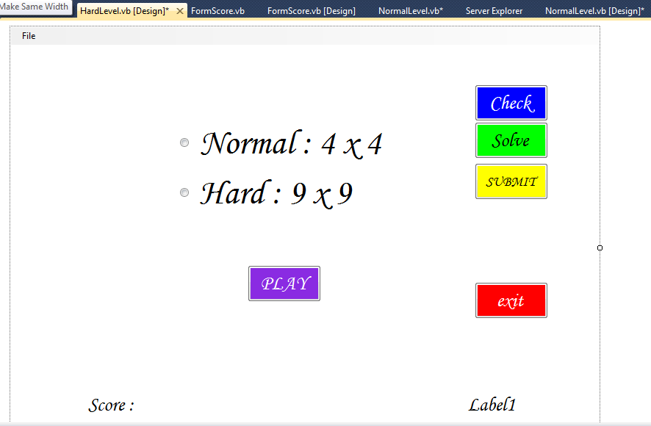

|  |
| --- |
| Public Class HardLevel  Public box As Integer = 9  Dim Jam, Menit, Detik, mDetik As Integer  Dim hard As Integer = 0  Dim hardini As Integer = 0  Dim normal As Integer = 0  Dim normalini As Integer = 0  Public score As Integer = 0  Dim mulai As Integer = 1  Dim check As Integer = 0  Dim backtracking As Boolean = False  Dim Bold As Font = New Font(Me.Font.FontFamily, Me.FontHeight + 17, FontStyle.Bold)  '----------------------------------------------------  ' FUNGSI RANDOM!  '----------------------------------------------------  Dim i As Integer  Dim j As Integer  Public Function GetRandom(ByVal Min As Integer, ByVal Max As Integer) As Integer  Dim Generator As System.Random = New System.Random()  Return Generator.Next(Min, Max)  End Function  Class sudoku_textbox  Inherits TextBox  Protected Overrides Sub OnKeyPress(ByVal e As System.Windows.Forms.KeyPressEventArgs)  If Char.IsDigit(e.KeyChar) Or e.KeyChar = " " Or e.KeyChar = ControlChars.Back Then  e.Handled = False  Else  e.Handled = True  End If  If e.KeyChar = " " Or e.KeyChar = "0" Then  e.KeyChar = ControlChars.Back  End If  If HardLevel.box = 4 Or NormalLevel.box = 4 Then  If e.KeyChar = "5" Or e.KeyChar = "6" Or e.KeyChar = "7" Or e.KeyChar = "8" Or e.KeyChar = "9" Then  e.KeyChar = ControlChars.Back  End If  End If  End Sub  End Class  Dim cell(0 To box - 1, 0 To box - 1) As sudoku_textbox  Dim grid(0 To box - 1, 0 To box - 1) As String  Private Sub Form1_Load(ByVal sender As Object, ByVal e As System.EventArgs) Handles Me.Load  Label1.Text = "00 : 00 : 00,00"  End Sub  '-----------------------------------------------------------------------------------------------------------  ' AREA NORMAL LEVEL COMMAND  '-----------------------------------------------------------------------------------------------------------  '-----------------------------  ' Normal Random  '-----------------------------  Private Sub random_normal()  For x As Integer = 0 To 3  If x = 0 Then  i = 0  j = GetRandom(1, 2)  cell(i, j).Text = 1  ElseIf x = 1 Then  i = 1  j = GetRandom(2, 3)  cell(i, j).Text = 2  ElseIf x = 2 Then  i = 2  j = GetRandom(3, 4)  cell(i, j).Text = 3  ElseIf x = 3 Then  i = 3  j = GetRandom(1, 3)  cell(i, j).Text = 4  End If  Next  score = 0  Label3.Text = score  End Sub  '***************************  ' Cell Normal 4x4  '***************************  Private Sub normal_cell()  Dim xxtra As Integer  Dim yxtra As Integer  For x As Integer = 0 To box - 1  For y As Integer = 0 To box - 1  cell(x, y) = New sudoku_textbox  cell(x, y).AutoSize = False  cell(x, y).ReadOnly = False  cell(x, y).Font = Bold  cell(x, y).Text = ""  cell(x, y).Width = 50  cell(x, y).Height = 50  cell(x, y).MaxLength = 1  cell(x, y).TextAlign = HorizontalAlignment.Center  If normal = 0 And normal = 0 Then  cell(x, y).Visible = False  Else  cell(x, y).Visible = True  End If  xxtra = 0  yxtra = 0  If x > 1 Then  xxtra = 4  End If  If x > 3 Then  xxtra = 8  End If  If y > 1 Then  yxtra = 4  End If  If y > 3 Then  yxtra = 8  End If  cell(x, y).Location = New Point(150 + x * 50 + xxtra, 150 + 50 * y + yxtra)  'End If  'cell(x, y).Location = New Point(x * 20, y * 20)  Me.Controls.Add(cell(x, y))  AddHandler cell(x, y).TextChanged, AddressOf cell_changed_normal  Next  Next  End Sub  '***************************  ' Ganti isi Cell Normal  '***************************  Private Sub cell_changed_normal()  If backtracking Then Return  For x As Integer = 0 To box - 1  For y As Integer = 0 To box - 1  grid(x, y) = cell(x, y).Text  cell(x, y).ForeColor = Color.Black  cell(x, y).BackColor = Color.White  Next  Next  score = score + 2  Label3.Text = score  For x = 0 To box - 1  For y = 0 To box - 1  If check_rows_normal(x, y) Then  If check_columns_normal(x, y) Then  If Not check_box_normal(x, y) Then  cell(x, y).ForeColor = Color.Red  cell(x, y).BackColor = Color.Yellow  score = score - 2  Label3.Text = score  End If  Else  cell(x, y).ForeColor = Color.Red  cell(x, y).BackColor = Color.Yellow  score = score - 2  Label3.Text = score  End If  Else  cell(x, y).ForeColor = Color.Red  cell(x, y).BackColor = Color.Yellow  score = score - 2  Label3.Text = score  End If  Next  Next  End Sub  '***************************  ' Cek Baris Cell Normal  '***************************  Function check_rows_normal(ByVal xsender, ByVal ysender) As Boolean  Dim noclash As Boolean = True  For x As Integer = 0 To box - 1  If grid(x, ysender) <> "" Then  If x <> xsender Then  If grid(x, ysender) = grid(xsender, ysender) Then  noclash = False  End If  End If  End If  Next  Return noclash  End Function  '***************************  ' Cek Kolom Cell Normal  '***************************  Function check_columns_normal(ByVal xsender, ByVal ysender) As Boolean  Dim noclash As Boolean = True  For y As Integer = 0 To box - 1  If grid(xsender, y) <> "" Then  If y <> ysender Then  If grid(xsender, y) = grid(xsender, ysender) Then  noclash = False  End If  End If  End If  Next  Return noclash  End Function  '***************************  ' Cek Box Cell Normal  '***************************  Function check_box_normal(ByVal xsender, ByVal ysender) As Boolean  Dim noclash As Boolean = True  Dim xstart As Integer  Dim ystart As Integer  If xsender < 2 Then  xstart = 0  ElseIf xsender < 4 Then  xstart = 2  End If  If ysender < 2 Then  ystart = 0  ElseIf ysender < 4 Then  ystart = 2  End If  For y As Integer = ystart To (ystart + 1)  For x As Integer = xstart To (xstart + 1)  If grid(x, y) <> "" Then  If Not (x = xsender And y = ysender) Then  If grid(x, y) = grid(xsender, ysender) Then  noclash = False  End If  End If  End If  Next  Next  Return noclash  End Function  '***************************  ' Problem Solve Normal  '***************************  Function backtrack_normal(ByVal x As Integer, ByVal y As Integer) As Boolean  Dim numbers As Integer = 1  If grid(x, y) = "" Then  Do  grid(x, y) = CStr(numbers)  If check_rows_normal(x, y) Then  If check_columns_normal(x, y) Then  If check_box_normal(x, y) Then  y = y + 1  If y = box Then  y = 0  x = x + 1  If x = box Then Return False  End If  If backtrack_normal(x, y) Then Return True  y = y - 1  If y < 0 Then  y = box - 1  x = x - 1  End If  End If  End If  End If  numbers = numbers + 1  Loop Until numbers = box + 1  grid(x, y) = ""  Return False  Else  y = y + 1  If y = box Then  y = 0  x = x + 1  If x = box Then Return True  End If  Return backtrack_normal(x, y)  End If  ' End If  End Function  '-----------------------------------------------------------------------------------------------------------  ' AREA HARD LEVEL COMMAND  '-----------------------------------------------------------------------------------------------------------  '-----------------------------  ' Normal Random  '-----------------------------  Private Sub random_hard()  For x As Integer = 0 To 8  '----------------------------------------------  ' Random Baris 1 - 3 | ( 0 - 2 )  '----------------------------------------------  If x = 0 Then  i = GetRandom(0, 2)  j = GetRandom(0, 2)  cell(i, j).Text = GetRandom(1, 2)  cell(i, j).ReadOnly = True  cell(i, j).BackColor = Color.Blue  i = GetRandom(0, 2)  j = GetRandom(0, 2)  cell(i, j).Text = GetRandom(3, 4)  cell(i, j).ReadOnly = True  cell(i, j).BackColor = Color.Blue  ElseIf x = 1 Then  i = GetRandom(0, 2)  j = GetRandom(3, 5)  cell(i, j).Text = GetRandom(5, 6)  cell(i, j).ReadOnly = True  cell(i, j).BackColor = Color.Blue  i = GetRandom(0, 2)  j = GetRandom(3, 5)  cell(i, j).Text = GetRandom(7, 8)  cell(i, j).ReadOnly = True  cell(i, j).BackColor = Color.Blue  ElseIf x = 2 Then  i = GetRandom(0, 2)  j = GetRandom(6, 8)  cell(i, j).Text = GetRandom(2, 3)  cell(i, j).ReadOnly = True  cell(i, j).BackColor = Color.Blue  i = GetRandom(0, 2)  j = GetRandom(6, 8)  cell(i, j).Text = GetRandom(4, 5)  cell(i, j).ReadOnly = True  cell(i, j).BackColor = Color.Blue  '----------------------------------------------  ' Random Baris 4 - 6 | ( 3 - 5 )  '----------------------------------------------  ElseIf x = 3 Then  i = GetRandom(3, 5)  j = GetRandom(0, 2)  cell(i, j).Text = GetRandom(5, 6)  cell(i, j).ReadOnly = True  cell(i, j).BackColor = Color.Blue  i = GetRandom(3, 5)  j = GetRandom(0, 2)  cell(i, j).Text = GetRandom(7, 8)  cell(i, j).ReadOnly = True  cell(i, j).BackColor = Color.Blue  ElseIf x = 4 Then  i = GetRandom(3, 5)  j = GetRandom(3, 5)  cell(i, j).Text = GetRandom(2, 3)  cell(i, j).ReadOnly = True  cell(i, j).BackColor = Color.Blue  i = GetRandom(3, 5)  j = GetRandom(3, 5)  cell(i, j).Text = GetRandom(4, 5)  cell(i, j).ReadOnly = True  cell(i, j).BackColor = Color.Blue  ElseIf x = 5 Then  i = GetRandom(3, 5)  j = GetRandom(6, 8)  cell(i, j).Text = GetRandom(1, 2)  cell(i, j).ReadOnly = True  cell(i, j).BackColor = Color.Blue  i = GetRandom(3, 5)  j = GetRandom(6, 8)  cell(i, j).Text = GetRandom(3, 4)  cell(i, j).ReadOnly = True  cell(i, j).BackColor = Color.Blue  '----------------------------------------------  ' Random Baris 7 - 9 | ( 6 - 8 )  '----------------------------------------------  ElseIf x = 6 Then  i = GetRandom(6, 8)  j = GetRandom(0, 2)  cell(i, j).Text = GetRandom(2, 3)  cell(i, j).ReadOnly = True  i = GetRandom(6, 8)  j = GetRandom(0, 2)  cell(i, j).Text = GetRandom(4, 5)  cell(i, j).ReadOnly = True  ElseIf x = 7 Then  i = GetRandom(6, 8)  j = GetRandom(3, 5)  cell(i, j).Text = GetRandom(1, 2)  cell(i, j).ReadOnly = True  i = GetRandom(6, 8)  j = GetRandom(3, 5)  cell(i, j).Text = GetRandom(3, 4)  cell(i, j).ReadOnly = True  ElseIf x = 8 Then  i = GetRandom(6, 8)  j = GetRandom(6, 8)  cell(i, j).Text = GetRandom(6, 7)  cell(i, j).ReadOnly = True  i = GetRandom(6, 8)  j = GetRandom(6, 8)  cell(i, j).Text = GetRandom(8, 9)  cell(i, j).ReadOnly = True  End If  Next  score = 0  Label3.Text = score  End Sub  '***************************  ' Cell Hard 9x9  '***************************  Private Sub hard_cell()  Dim xxtra As Integer  Dim yxtra As Integer  For x As Integer = 0 To box - 1  For y As Integer = 0 To box - 1  cell(x, y) = New sudoku_textbox  cell(x, y).AutoSize = False  cell(x, y).ReadOnly = False  cell(x, y).Font = Bold  cell(x, y).Text = ""  cell(x, y).Width = 50  cell(x, y).Height = 50  cell(x, y).MaxLength = 1  cell(x, y).TextAlign = HorizontalAlignment.Center  If normal = 0 And hard = 0 Then  cell(x, y).Visible = False  Else  cell(x, y).Visible = True  End If  xxtra = 0  yxtra = 0  If x > 2 Then  xxtra = 4  End If  If x > 5 Then  xxtra = 8  End If  If y > 2 Then  yxtra = 4  End If  If y > 5 Then  yxtra = 8  End If  cell(x, y).Location = New Point(75 + x * 50 + xxtra, 75 + 50 * y + yxtra)  'End If  'cell(x, y).Location = New Point(x * 20, y * 20)  Me.Controls.Add(cell(x, y))  AddHandler cell(x, y).TextChanged, AddressOf cell_changed_hard  Next  Next  End Sub  '***************************  ' Ganti isi Cell Hard  '***************************  Private Sub cell_changed_hard()  If backtracking Then Return  For x As Integer = 0 To box - 1  For y As Integer = 0 To box - 1  grid(x, y) = cell(x, y).Text  cell(x, y).ForeColor = Color.Black  cell(x, y).BackColor = Color.White  Next  Next  score = score + 2  Label3.Text = score  For x = 0 To box - 1  For y = 0 To box - 1  If check_rows_hard(x, y) Then  If check_columns_hard(x, y) Then  If Not check_box_hard(x, y) Then  cell(x, y).ForeColor = Color.Red  cell(x, y).BackColor = Color.Yellow  score = score - 2  Label3.Text = score  End If  Else  cell(x, y).ForeColor = Color.Red  cell(x, y).BackColor = Color.Yellow  score = score - 2  Label3.Text = score  End If  Else  cell(x, y).ForeColor = Color.Red  cell(x, y).BackColor = Color.Yellow  score = score - 2  Label3.Text = score  End If  Next  Next  End Sub  '***************************  ' Cek Baris Cell Hard  '***************************  Function check_rows_hard(ByVal xsender, ByVal ysender) As Boolean  Dim noclash As Boolean = True  For x As Integer = 0 To box - 1  If grid(x, ysender) <> "" Then  If x <> xsender Then  If grid(x, ysender) = grid(xsender, ysender) Then  noclash = False  End If  End If  End If  Next  Return noclash  End Function  '***************************  ' Cek Kolom Cell Hard  '***************************  Function check_columns_hard(ByVal xsender, ByVal ysender) As Boolean  Dim noclash As Boolean = True  For y As Integer = 0 To box - 1  If grid(xsender, y) <> "" Then  If y <> ysender Then  If grid(xsender, y) = grid(xsender, ysender) Then  noclash = False  End If  End If  End If  Next  Return noclash  End Function  '***************************  ' Cek Box Cell Hard  '***************************  Function check_box_hard(ByVal xsender, ByVal ysender) As Boolean  Dim noclash As Boolean = True  Dim xstart As Integer  Dim ystart As Integer  If xsender < 3 Then  xstart = 0  ElseIf xsender < 6 Then  xstart = 3  Else  xstart = 6  End If  If ysender < 3 Then  ystart = 0  ElseIf ysender < 6 Then  ystart = 3  Else  ystart = 6  End If  For y As Integer = ystart To (ystart + 2)  For x As Integer = xstart To (xstart + 2)  If grid(x, y) <> "" Then  If Not (x = xsender And y = ysender) Then  If grid(x, y) = grid(xsender, ysender) Then  noclash = False  End If  End If  End If  Next  Next  Return noclash  End Function  '***************************  ' Problem Solve Hard  '***************************  Function backtrack_hard(ByVal x As Integer, ByVal y As Integer) As Boolean  Dim numbers As Integer = 1  If grid(x, y) = "" Then  Do  grid(x, y) = CStr(numbers)  If check_rows_hard(x, y) Then  If check_columns_hard(x, y) Then  If check_box_hard(x, y) Then  y = y + 1  If y = box Then  y = 0  x = x + 1  If x = box Then Return False  End If  If backtrack_hard(x, y) Then Return True  y = y - 1  If y < 0 Then  y = box - 1  x = x - 1  End If  End If  End If  End If  numbers = numbers + 1  Loop Until numbers = box + 1  grid(x, y) = ""  Return False  Else  y = y + 1  If y = box Then  y = 0  x = x + 1  If x = box Then Return True  End If  Return backtrack_hard(x, y)  End If  ' End If  End Function  '-----------------------------------------------------------------------------------------------------------  ' BUTTON - BUTTON  '-----------------------------------------------------------------------------------------------------------  'Private Sub ButtonClear_Click(ByVal sender As Object, ByVal e As System.EventArgs)  ' Dim result As MsgBoxResult = MessageBox.Show("Do you want to clear the puzzle?", "Clear", MessageBoxButtons.YesNo, MessageBoxIcon.Question)  ' If result = vbYes Then  ' For x As Integer = 0 To box - 1  ' For y As Integer = 0 To box - 1  ' cell(x, y).ReadOnly = False  ' cell(x, y).BackColor = Color.White  ' cell(x, y).Text = ""  ' Next  ' Next  ' score = 0  ' Timer1.Enabled = False  ' Label1.Text = "00 : 00 : 00,00"  ' Timer1.Enabled = True  ' End If  ' If normal = 1 Then  ' random_normal()  ' End If  ' If hard = 1 Then  ' random_hard()  ' End If  'End Sub  Private Sub ButtonSolve_Click(ByVal sender As Object, ByVal e As System.EventArgs) Handles ButtonSolve.Click  backtracking = True  For x As Integer = 0 To box - 1  For y As Integer = 0 To box - 1  If cell(x, y).Text = "" Then  score = score - 2  End If  Next  Next  For x As Integer = 0 To box - 1  For y As Integer = 0 To box - 1  grid(x, y) = cell(x, y).Text  Next  Next  backtrack_hard(0, 0)  backtrack_normal(0, 0)  'If hard = 1 Then  For x = 0 To box - 1  For y = 0 To box - 1  cell(x, y).Text = grid(x, y)  cell(x, y).BackColor = Color.Green  Next  Next  'End If  backtracking = False  End Sub  Private Sub Button1_Click(ByVal sender As System.Object, ByVal e As System.EventArgs) Handles Button1.Click  Me.Close()  End Sub  '-----------------------------------------------------------------------------------------------------------  ' BUTTON DAN RADIO BUTTON  '-----------------------------------------------------------------------------------------------------------  Private Sub Button3_Click(sender As Object, e As EventArgs) Handles Button3.Click  If RadioButton2.Checked Then  If mulai = 1 Then  score = 0  Label3.Text = score  Timer1.Enabled = True  Button1.Visible = True  Button2.Visible = False  Button3.Visible = False  ButtonSolve.Visible = False  Button4.Visible = True  RadioButton2.Visible = False  RadioButton3.Visible = False  box = 4  normal = 1  normalini = 1  hard = 0  hardini = 0  normal_cell()  random_normal()  mulai = 0  ElseIf hard = 1 And hardini = 1 And box = 9 Then  score = 0  Label3.Text = score  Me.Hide()  NormalLevel.box = 4  NormalLevel.Show()  Else  score = 0  Label3.Text = score  Timer1.Enabled = True  Button1.Visible = True  Button2.Visible = True  Button3.Visible = False  ButtonSolve.Visible = True  Button4.Visible = True  RadioButton2.Visible = False  RadioButton3.Visible = False  box = 4  normal = 1  normalini = 1  hard = 0  hardini = 0  For x As Integer = 0 To box - 1  For y As Integer = 0 To box - 1  cell(x, y).ReadOnly = False  cell(x, y).BackColor = Color.White  cell(x, y).Text = ""  cell(x, y).Show()  Next  Next  random_normal()  End If  End If  If RadioButton3.Checked Then  If mulai = 1 Then  score = 0  Label3.Text = score  Timer1.Enabled = True  Button1.Visible = True  Button2.Visible = True  Button3.Visible = False  ButtonSolve.Visible = True  Button4.Visible = True  RadioButton2.Visible = False  RadioButton3.Visible = False  box = 9  normal = 0  normalini = 0  hard = 1  hardini = 1  hard_cell()  random_hard()  mulai = 0  ElseIf normal = 1 And normalini = 1 And box = 4 Then  score = 0  Label3.Text = score  Me.Hide()  NormalLevel.box = 9  NormalLevel.Show()  Else  score = 0  Label3.Text = score  Timer1.Enabled = True  Button1.Visible = True  Button2.Visible = True  Button3.Visible = False  ButtonSolve.Visible = True  Button4.Visible = True  RadioButton2.Visible = False  RadioButton3.Visible = False  box = 9  normal = 0  normalini = 0  hard = 1  hardini = 1  For x As Integer = 0 To box - 1  For y As Integer = 0 To box - 1  cell(x, y).ReadOnly = False  cell(x, y).BackColor = Color.White  cell(x, y).Text = ""  cell(x, y).Show()  Next  Next  random_hard()  End If  End If  End Sub  Private Sub NewGameToolStripMenuItem_Click(sender As Object, e As EventArgs) Handles NewGameToolStripMenuItem.Click  Dim result As MsgBoxResult = MessageBox.Show("Do you want to clear the puzzle?", "New Game", MessageBoxButtons.YesNo, MessageBoxIcon.Question)  If result = vbYes Then  For x As Integer = 0 To box - 1  For y As Integer = 0 To box - 1  cell(x, y).ReadOnly = False  cell(x, y).BackColor = Color.White  cell(x, y).Text = ""  cell(x, y).Hide()  Next  Next  Timer1.Enabled = False  Label1.Text = "00 : 00 : 00,00"  Jam = 0  Menit = 0  Detik = 0  mDetik = 0  ButtonSolve.Enabled = True  Button2.Enabled = True  End If  Button1.Visible = False  Button2.Visible = False  Button3.Visible = True  ButtonSolve.Visible = False  Button4.Visible = False  RadioButton2.Visible = True  RadioButton3.Visible = True  If normal = 1 Then  random_normal()  End If  If hard = 1 Then  random_hard()  End If    End Sub  Private Sub Button2_Click(sender As Object, e As EventArgs) Handles Button2.Click  If check = 0 Then  backtracking = True  For x As Integer = 0 To box - 1  For y As Integer = 0 To box - 1  grid(x, y) = cell(x, y).Text  Next  Next  backtrack_hard(0, 0)  backtrack_normal(0, 0)  'If hard = 1 Then  For x = 0 To box - 1  For y = 0 To box - 1  If cell(x, y).Text = grid(x, y) Then  cell(x, y).BackColor = Color.Green  Else  cell(x, y).BackColor = Color.Red  End If  Next  Next  'End If  backtracking = False  check = 1  ElseIf check = 1 Then  For x = 0 To box - 1  For y = 0 To box - 1  cell(x, y).BackColor = Color.White  Next  Next  check = 0  End If  End Sub  Private Sub Timer1_Tick(sender As Object, e As EventArgs) Handles Timer1.Tick  mDetik += 1  If mDetik = 100 Then  mDetik = 0  Detik += 1  If Detik Mod 10 = 0 Then  score = score - 4  End If  If Detik = 60 Then  Detik = 0  Menit += 1  If Menit = 60 Then  Menit = 0  Jam += 1  End If  End If  End If  Label3.Text = score  Label1.Text = Format(Jam, "00") & " : " & Format(Menit, "00") & " : " & Format(Detik, "00") & "," & Format(mDetik, "00")  End Sub  Private Sub ExitToolStripMenuItem_Click(sender As Object, e As EventArgs) Handles ExitToolStripMenuItem.Click  End  End Sub  Private Sub Button4_Click(sender As Object, e As EventArgs) Handles Button4.Click  FormScore.Show()  Timer1.Enabled = False  ButtonSolve.Enabled = False  Button2.Enabled = False  End Sub  End Class |

1. **Aturan Permainan**
2. Program akan menampilkan tampilan utamanya. Setelah itu *user* disarankan untuk memilih salah satu diantara dua pilihan pada radiobutton yang ada yaitu *Lowlevel* dan *Hardlevel*
3. Setelah memilih salah satu dari kedua pilihan yang ada tersebut (misalnya saja memilih Hardlevel), selanjutnya *user* disarankan untuk memilih dan mengklik button PLAY
4. Kemudian program akan melakukan pemrosesan, setelah itu program akan menampilkan form HardLevel tersebut, pada level ini terdapat 9x9 kotak yang harus diisi dengan angka yang berbeda pada setiap kotaknya disetiap diagonal. Apabila angka yang diisikan tidak sesuai maka warna dari angka yang dimasukkan akan berubah menjadi merah
5. Pada form ini juga terdapat beberapa button diantaranya yaitu Check, Solve, Submit, dan exit. Button Check digunakan untuk mengecek jawabanan kita apakah benar atau tidak, dan melalui button check ini kita dapat mengetahui apakah isian yang dimasukkan benar atau tidak. Button solve ini digunakan apabila kita telah menyerah dalam permainan game sudoku ini, aabila button solve ini di pilih dan klik maka kotak kosong akan terisi dengan sendirinya dengan jawaban yang sesuai. Button Submit digunakan apabila kita telah mengisi kotak yang kosong tersebut, setelah button ini dipilih dan klik, maka program akan menampilkan nilai yang didapatkan setelah kita mengisi kotak yang kosong pada permainan sudoku ini.
6. Disamping itu, pada saat pertama kali kita memilih permainan pada level HardLevel ini, waktu akan otomatis berjalan, dan setiap 2 menit secara otomatis angka kita akan berkurang 2 point hal ini karena program ini menggunakan sistem pinalty, artinya nilai akan terus berkurang apabila kita terlalu lama dalam menyelesaikan game tersebut.
7. Tambahan apabila kita memilih dan mengklik button solve, dengan sendirinya apabila kita memilih dan mengklik button submit maka score kita akan -144
8. Lalu apabila kita ingin memulai game baru, kita hanya perlu memilih dan mengklik menu File-New Game (atau dengan menekan tombol F2 pada keyboard), dan apabila kita ingin mengakhiri permainan kita dapat memilih menu File-Exit (atau dengan menekan X pada keyboard) dan bisa juga dilakukan dengan memilih dan mengklik button EXIT yang telah tersedia pada setiap form yang ditampilkan.
9. **Printscreen Jalannya Game Sudoku**

Tampilan awal

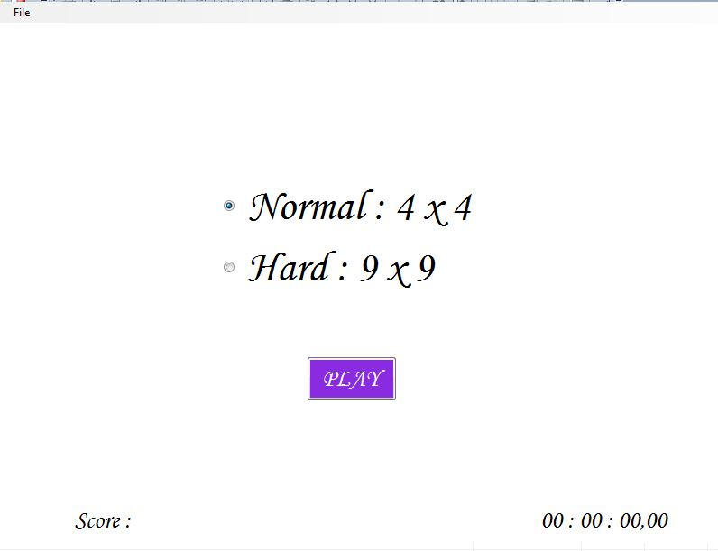

Tampilan apabila kita memilih radiobutton Normal, pada saat kita telah memilih level tersebut, secara otomatis timer akan berjalan seperti yang ditampilkan pada gambar dibawah ini

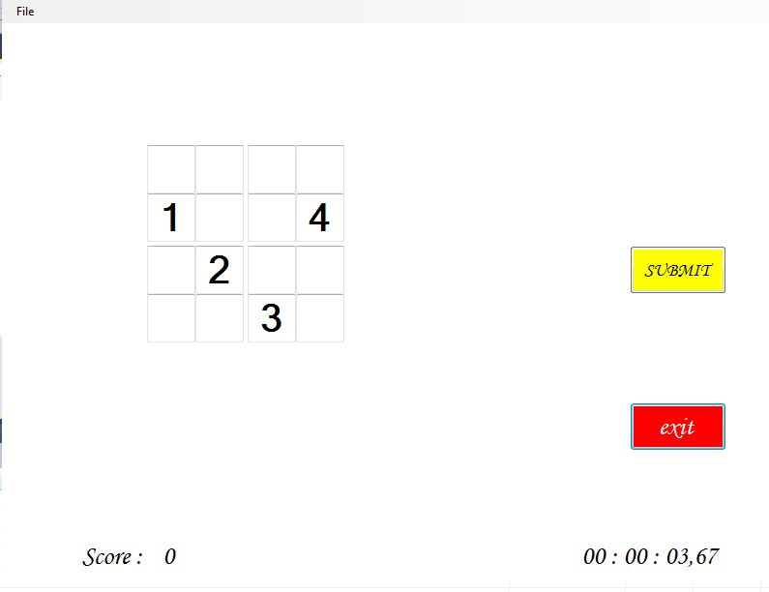

Tampilan pada NormalLevel pada saat kita telah selesai mengisi kotak pada game ini. Pada tampilan di form ini akan ditampilkan score yang didapat dan waktu yang dibutuhkan untuk menyelesaikan level ini

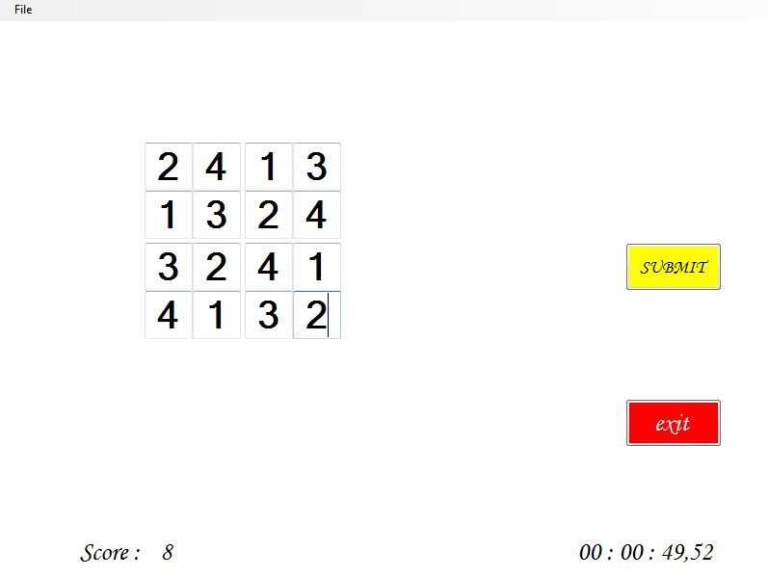

Lalu apabila kita mengklik button submit, maka akan ditampilkan score yang didapat sepaerti pada gambar berikut ini

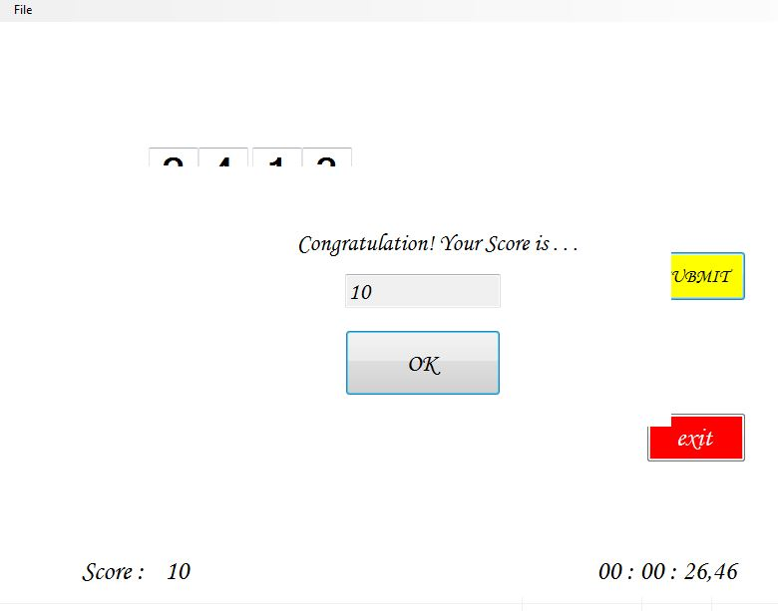

Lalu apabila kita ingin melanjutkan game, setelah tampilan diatas kita pilih OK. Lalu pada menu File pilih New Game, dan form utama akan ditampilan seperti pada gambar berikut ini

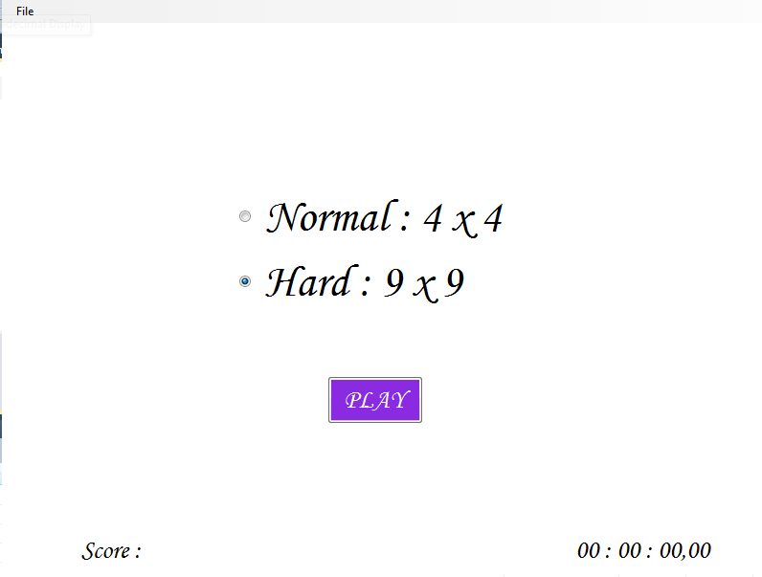

Setelah itu form HardLevel akan ditampilkan

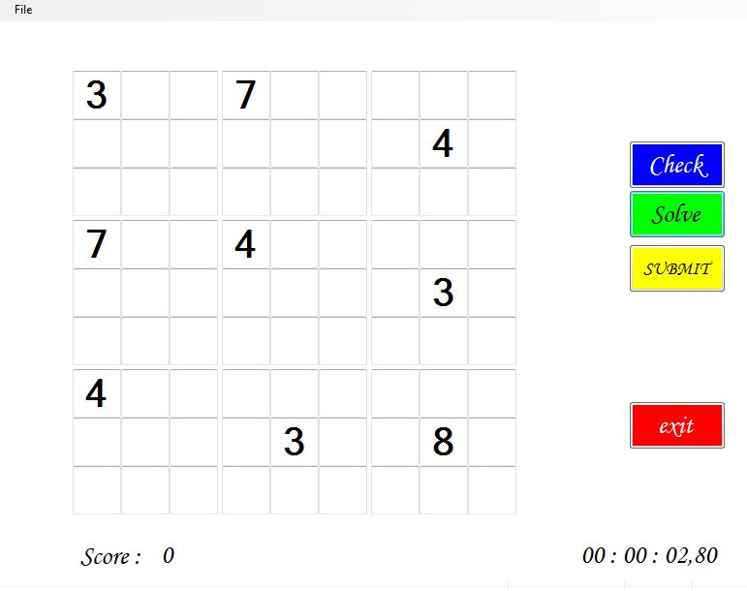

Apabila kita memilih dan mengklik tombol check, maka akan tampil gambar seperti berikut ini,

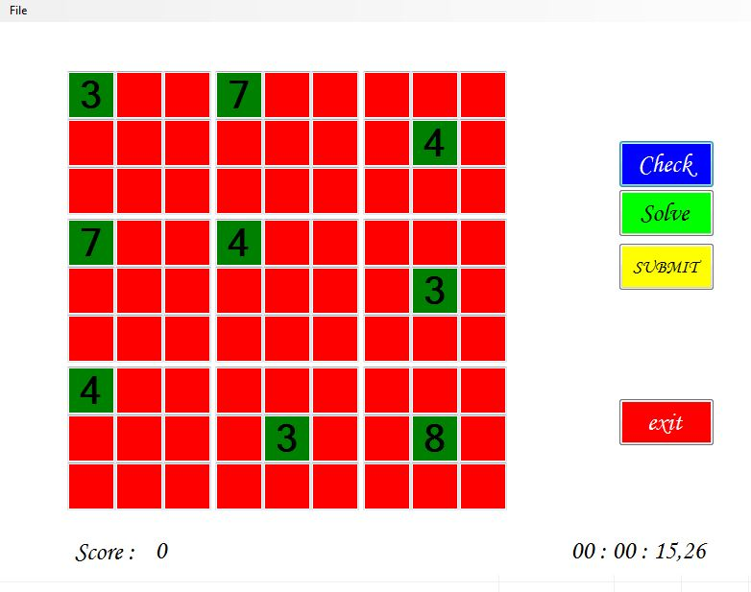

Apabila kita memilih dan mengklik tombol solve, maka akan tampil gambar seperti berikut ini, semua kotak yang awalnya kosong akan terisi :

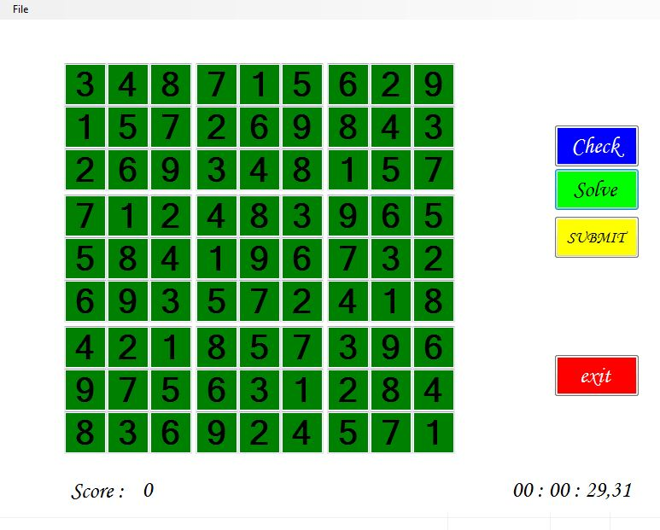

Setelah kita meklik solve tersebut, lalu kita klik submit maka nilai yang ditampilkan akan nampak seerti pada gambar berikut, score tersebut akan menjadi -144

